Sequence Detector (Verilog) – Case Study

Report

G.S. Umair Ahmadh

[umaireravur@gmail.com](mailto:umaireravur@gmail.com)

15.04.2020

1) Sequence diagram for the design

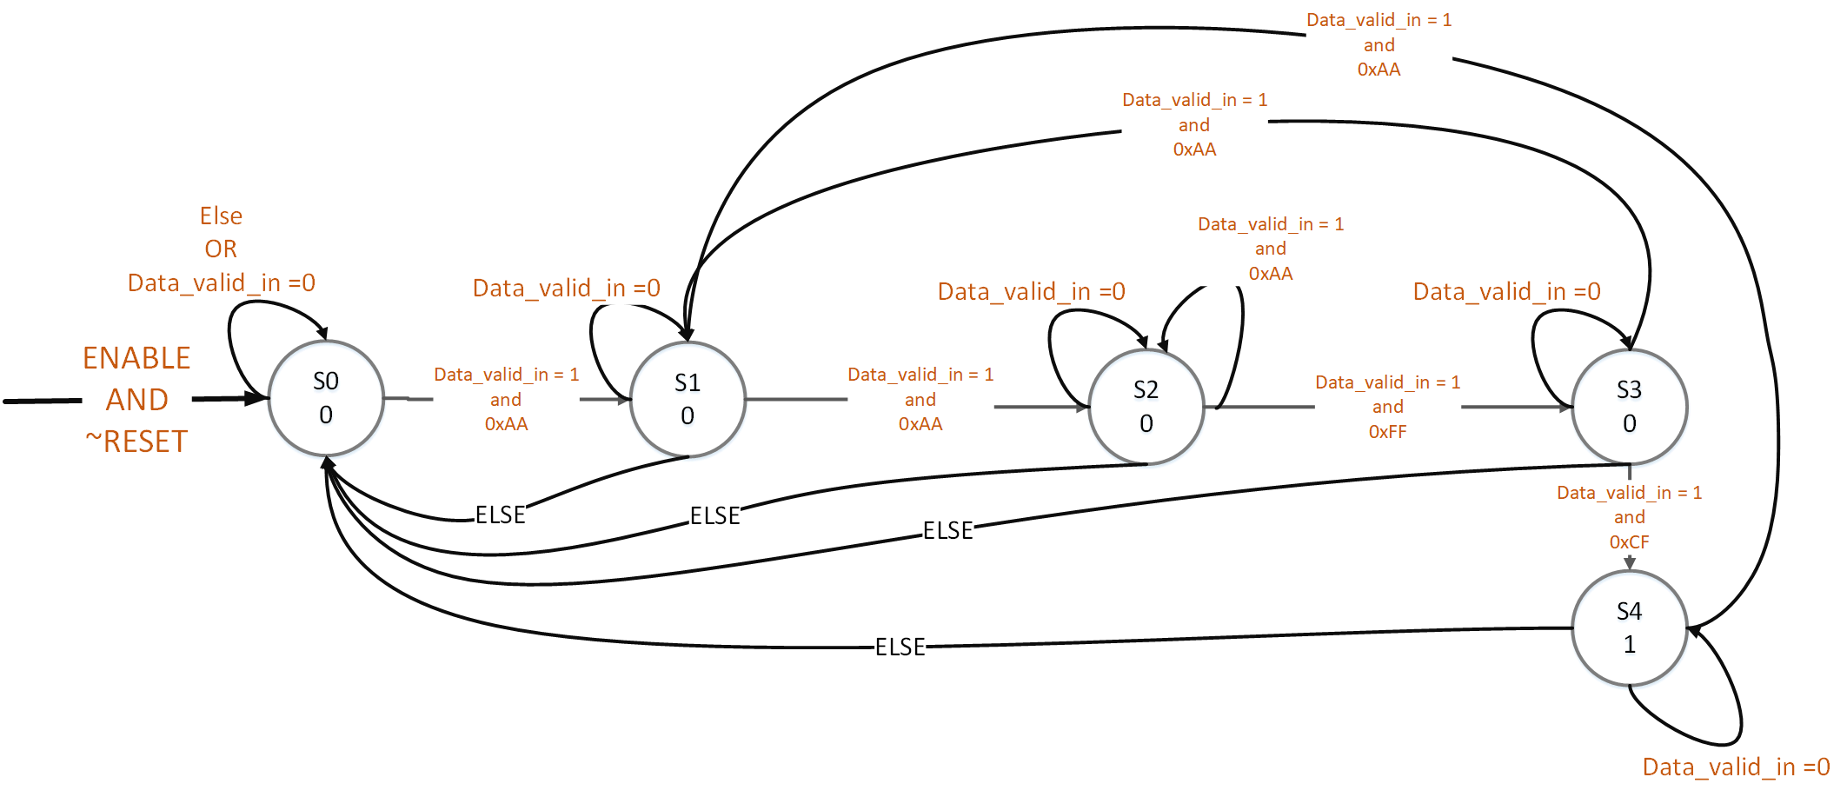

2) Verilog Design file

|  |
| --- |
| //Sequence detection (case study)  `timescale 1ns / 1ps  module SQD(  //defining input ports  input[7:0] data_in,  input reset,  input clk,  input enable,  input data_valid_in,  //output ports  output reg detected_out = 0,  output reg data_valid_out  );  //states  parameter S0 = 3'b000,  S1 = 3'b001,  S2 = 3'b011,  S3 = 3'b010,  S4 = 3'b110;  //registers to track current and next states  reg [2:0] current_state, next_state;  //For each clocks, for the purpose of updating the state, if the reset goes high, current state will be S0  //if enable goes low, state will go to S0  //Else: the next state will be updated as the current state  always @ (posedge clk, posedge reset, posedge enable)  begin  if(reset==1 | enable==0)  current_state <= S0;  else  current_state <= next_state;  end  //wheneever the current state or the data_in or data_valid_in changes, it has to determine  //which state is going to be the next  always @(current_state, data_in, data_valid_in)  begin  if(enable ==1)  if(data_valid_in ==1)  case(current_state)  S0:begin  if(data_in == 8'hAA)  next_state <= S1;  else  next_state <= S0;  end    S1:begin  if(data_in ==8'hAA)  next_state <= S2;  else  next_state <= S0;  end    S2:begin  if(data_in ==8'hFF)  next_state <= S3;  else if(data_in ==8'hAA)  next_state <= S2;  else  next_state <= S0;  end    S3:begin  if(data_in ==8'hCF)  next_state <= S4;  else if(data_in ==8'hAA)  next_state <= S1;  else  next_state <= S0;  end    S4:begin  if(data_in ==8'hAA)  next_state <= S1;  else if(data_in ==8'hAA)  next_state <= S1;  else  next_state <= S0;  end  default: next_state<=S0;  endcase  else next_state <= current_state;    else next_state <= S0;  end    //checking for output    always @(current_state)  begin  case(current_state)  S0: begin data_valid_out <= 0; detected_out <= 0; end  S1: begin data_valid_out <= 0; detected_out <= 0; end  S2: begin data_valid_out <= 0; detected_out <= 0; end  S3: begin data_valid_out <= 0; detected_out <= 0; end  S4: begin data_valid_out <= 1; detected_out <= 1; end  default: begin data_valid_out <= 0; detected_out <= 0; end  endcase  end  endmodule |

3. Self-checking test bench

|  |
| --- |
| `timescale 1ns / 1ps  module testbench;  //inputs  reg [7:0] data_in;  reg reset;  reg clk;  reg enable;  reg data_valid_in;  //outputs  wire detected_out;  wire data_valid_out;    //Unit under Test  SQD uut (  .data_in(data_in),  .reset(reset),  .clk(clk),  .enable(enable),  .data_valid_in(data_valid_in),    .detected_out(detected_out),  .data_valid_out(data_valid_out)    );    initial begin  clk = 0;  forever #5 clk =~clk;  end  initial  begin  data_valid_in =0;  data_in = 8'h00;  reset = 1;  enable = 0;    #30;  reset = 0;  enable = 1;  data_valid_in =1;  #40;  data_in = 8'hAA;  #20;  data_in = 8'hFF;    #10;  data_valid_in =0;  data_in = 8'hCF;    #10;  data_valid_in =1;  data_in = 8'hCF;  #10;  data_in = 8'hEF;  #10;  data_in = 8'hFF;  #10;  data_in = 8'hAA;  #20;  data_in = 8'hFF;  #10;  data_in = 8'hCF;  #10;    data_in = 8'hAA;  #20;  data_in = 8'hFF;  #10;  //trying to reset in the middle of the sequence  reset = 1;  data_in = 8'hCF;  #10;  reset = 0;  data_in = 8'hCF;  #10;  data_in = 8'hAA;  #20;  data_in = 8'hFF;  #10;  data_in = 8'hCF;  #10;      #10 $finish;  end    endmodule |

4) Test Result (Behavioral Simulation)

